MEMORANDUM

TO: Michael McGovern, Town Manager
FROM: Maureen O'Meara, Town Planner
DATE: August 11, 2016
SUBJECT: Paper Street project status

In preparation for September 12th public hearing, below is a status report.

1. Draft Town Council paper street recommendations. As a result of the May 19th and June 22nd workshops, the Town Council has made recommendations for all but 5 paper streets. Below is a summary of the remaining paper streets.

•Surfside Ave - The Town Council has not made a draft recommendation to extend, accept or vacate this street. To avoid inadvertently omitting this street from final action, it is included on the "extend" list at this time.

•Atlantic Place - same as Surfside Ave above.

•Lydon Lane - Staff have reviewed subdivision plans in the area of Lydon Lane. While the Assessing maps do show a private road extending from Mitchell Rd to McAuley Rd, only the portion in the area of Campion Rd to McAuley Rd is shown on a subdivision plan. (see attached composite map of subdivision plans). There appears to be no paper street rights that connect back to Mitchell Rd. There does appear to be about 85' of Lydon Lane extending east from the intersection with Campion. The Town may choose to act on the 85' length, but without the connection to Mitchell Rd, no benefit has been identified by staff. To avoid inadvertently omitting this street segment from final action, Lydon Lane (which would comprise only 85') is included on the "extend" list at this time.

•Spoondrift (north) and (west) - These segments are labeled on the subdivision plan as "private way." For this reason, Town Attorney Durward Parkinson has advised that they are not paper streets. These streets are not included on the lists for council action.

2. Town Council motions for consideration. Attached are 3 motions for Town Council action to extend, accept and vacate paper streets. Town Attorney Durward Parkinson has drafted these and recommends three separate motions and votes.

3. Paper Street Report. The 2015 Paper Street report has been updated to August 2, 2016 and will be posted to the town website.

Lydon Lane Subdivision plans composite

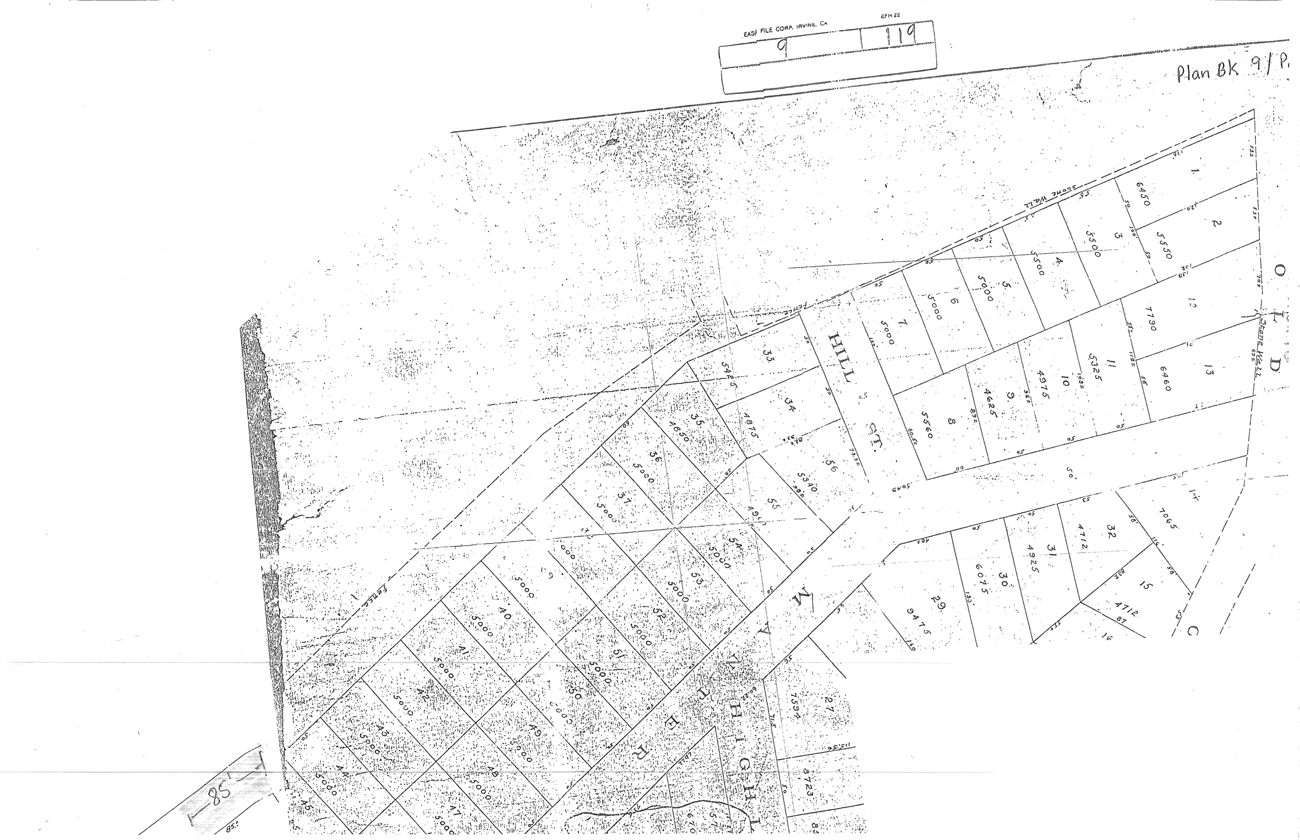
Mitchell Rd

85' section

ORDER
(ACCEPTANCE OF PAPER STREETS)

WHEREAS, pursuant to 23 M.R.S. § 3032, proposed and unaccepted ways also known as “paper streets” as shown on subdivision plans prior to September 29, 1987 shall be deemed vacated on September 29, 1997, unless extended a period of twenty (20) years by the Town Council, and
WHEREAS, on September 8, 1997, the Town Council voted to extend, for a period of twenty (20) years until September 29, 2017, all proposed and unaccepted ways within the Town of Cape Elizabeth except certain ways specifically denoted in the Order recorded in the Cumberland County Registry of Deeds (Document #054366).

WHEREAS, the Town Council wishes to formally accept certain to the paper streets previously extended and reserved by the aforesaid September 8, 1997 vote.

WHEREFORE, the Town Council, pursuant to 23 M.R.S. § 3032(2), hereby accepts the paper streets as shown on Exhibit A for the limited purposes described for each paper street.

The Town Clerk shall record an attested copy of this Order in the Cumberland County Registry of Deeds.

Dated at Cape Elizabeth, Maine, this ________ day of __________________, 2016.

___________________________________ __________________________________

___________________________________ __________________________________

____________________________________ ___________________________________

____________________________________________

Exhibit A - Page 1 of 2
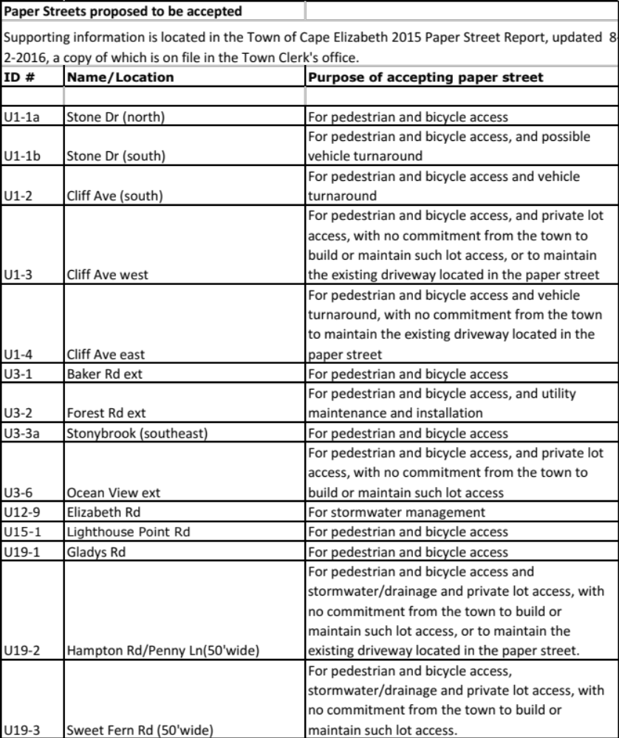
Exhibit A - Page 2 of 2
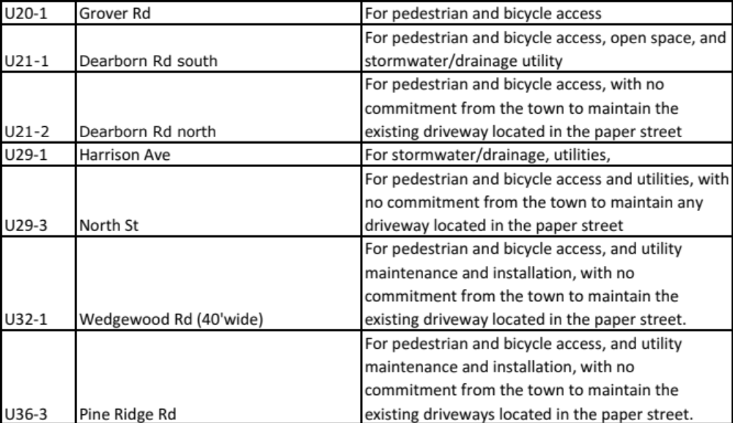

ORDER
(DEEMED VACATION OF PAPER STREETS)

WHEREAS, pursuant to 23 M.R.S. § 3032, proposed and unaccepted ways also known as “paper streets” as shown on subdivision plans prior to September 29, 1987 shall be deemed vacated on September 29, 1997, unless extend a period of twenty (20) years by the Town Council, and

WHEREAS, on September 8, 1997, the Town Council voted to extend, for a period of twenty (20) years until September 29, 2017, all proposed and unaccepted ways within the Town of Cape Elizabeth except certain ways specifically denoted in the Order recorded in the Cumberland County Registry of Deeds (Document #054366).

WHEREAS, the Town Council pursuant to 23 M.R.S. § 3032, voted to not further extend the time for acceptance of the paper streets as shown on Exhibit A with the intention that they will be deemed vacated under statute.

The Town Clerk shall record an attested copy of this Order in the Cumberland County Registry of Deeds.

Dated at Cape Elizabeth, Maine, this ________ day of __________________, 2016.

___________________________________ __________________________________

___________________________________ __________________________________

____________________________________ ___________________________________

____________________________________________

Exhibit A

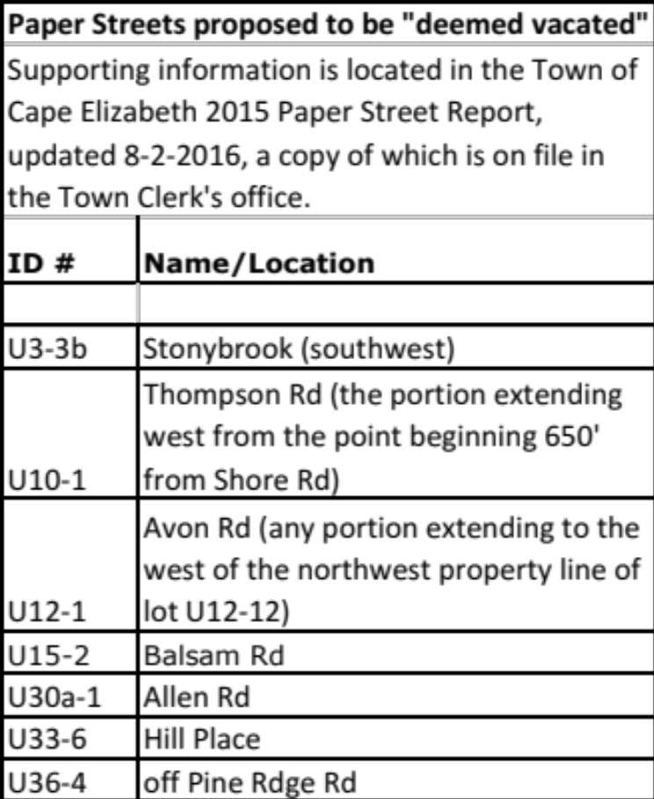

ORDER
(EXTENSION OF PAPER STREETS)

WHEREAS, pursuant to 23 M.R.S. § 3032, proposed and unaccepted ways also known as “paper streets” as shown on subdivision plans prior to September 29, 1987 shall be deemed vacated on September 29, 1997, unless extended a period of twenty (20) years by the Town Council, and

WHEREAS, on September 8, 1997, the Town Council voted to extend, for a period of twenty (20) years until September 29, 2017, all proposed and unaccepted ways within the Town of Cape Elizabeth except certain ways specifically denoted in the Order recorded in the Cumberland County Registry of Deeds (Document #054366).

WHEREAS, some proposed, unaccepted ways may have public benefit to the Town either as, public ways, pedestrian easements, utilities or for other purposes, in the future, the extent of which is difficult to determine.

WHEREFORE, The Town Council, pursuant to 23 M.R.S. § 3032(2) hereby extends for a period of twenty (20) years the proposed, unaccepted ways within the Town of Cape Elizabeth as shown on Exhibit A. To the extent that any paper streets in the Town of Cape Elizabeth have not been accepted or deemed vacated by vote the Council, their status as paper streets shall also be extended for a period of twenty (20) years.

The Town Clerk shall record an attested copy of this Order in the Cumberland County Registry of Deeds.

Dated at Cape Elizabeth, Maine, this ________ day of __________________, 2016.

___________________________________ __________________________________

___________________________________ __________________________________

____________________________________ ___________________________________

____________________________________________
Exhibit A



